Serverless URL Monitor – Use Lambda & CloudWatch to check website uptime.

Introduction
A serverless URL monitor helps check website uptime using AWS Lambda and CloudWatch. AWS Lambda functions execute on a scheduled interval to send HTTP requests to a specified URL and log the response. CloudWatch Alarms notify users if the website is down. This eliminates the need for a dedicated server, reducing costs and management overhead.

In simpler words:
AWS Lambda will check a website URL every few minutes → CloudWatch will watch the result → If site is down, it will send an alert.
Services Used:
AWS Lambda – Runs the monitoring Code
IAM Role – Gives access to lambda, cloudwatch
Cloudwatch Logs – Stores execution logs and monitoring output
Amazon Eventbridge – Triggers Lambda on a schedule (eg: every five minutes)
Amazon SNS – Send alert notifications when site is down
Python (urllib, boto3) - Used HTTP checks and AWS Integrations
Amazon S3 – Used to host a static test website

Architecture Flow Diagram
+----------------------+
| Amazon EventBridge |
| (Schedule: 5 minutes)|
+----------+-----------+
|
| Triggers
v
+----------------------+
| AWS Lambda |
| URL Monitor Function|
+----------+-----------+
|
| Reads Environment Variables
| - MONITOR_URL
| - SNS_TOPIC_ARN
v
+----------------------+
| HTTP Request to |
| Website URL |
+----------+-----------+
|
| Gets Response
v
+-------------------------------+
| Check HTTP Status Code |
+---------------+---------------
|
+----------+----------+
| |
v v
+-----------+ +-------------------+
| Status=200| | Status!=200 OR |
| Website UP| | Not Reachable |
+-----+-----+ +---------+---------+
| |
| |
v v
+-------------------+ +----------------------+
| Log to CloudWatch | | Send Alert via SNS |
| "Website is UP" | | (Email / SMS) |
+-------------------+ +----------+-----------+
|
v
+----------------------+
| CloudWatch Logs |
| (Store error logs) |
+----------------------+

Simple Flow Diagram

EventBridge (Timer)
↓
Lambda
↓
Check Website
↓
Is status 200?
/ \
Yes No
| |
Log OK Send SNS Alert
| |
CloudWatch CloudWatch Logs

Steps to follow:
- Created an IAM Role (permission for lambda to write logs, CloudWatch logs for monitoring).
- Created a Lambda function added a python code to
- Reads website URL from environment variables.
- Sends an HTTP request to the website.
- Check the response status code.
- If status is 200 (OK):
- Logs: “Website is UP” in CloudWatch
- If status is not 200 or site is unreachable:
- Send an SNS alert notification (Email)
- Logs the error in CloudWatch
- Amazon Event Bridge Scheduler by sets the rule and triggers the lambda function every 5 minutes.
- Sets an Amazon SNS notification and created subscription through an email to send an alert notification.
- Amazon S3 bucket creates a simple static test website and makes that URL for monitor URL when the status in 200 it shows as website up.

Output Samples:
Cloudwatch Logs:
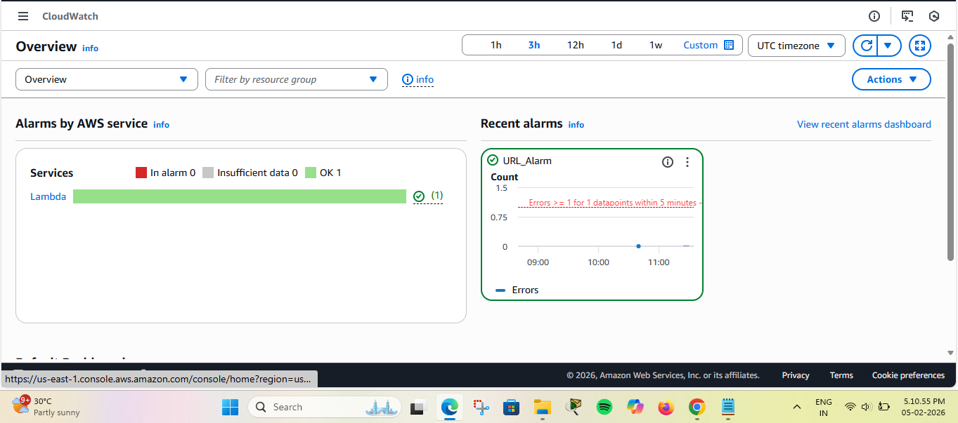
If status is 200:
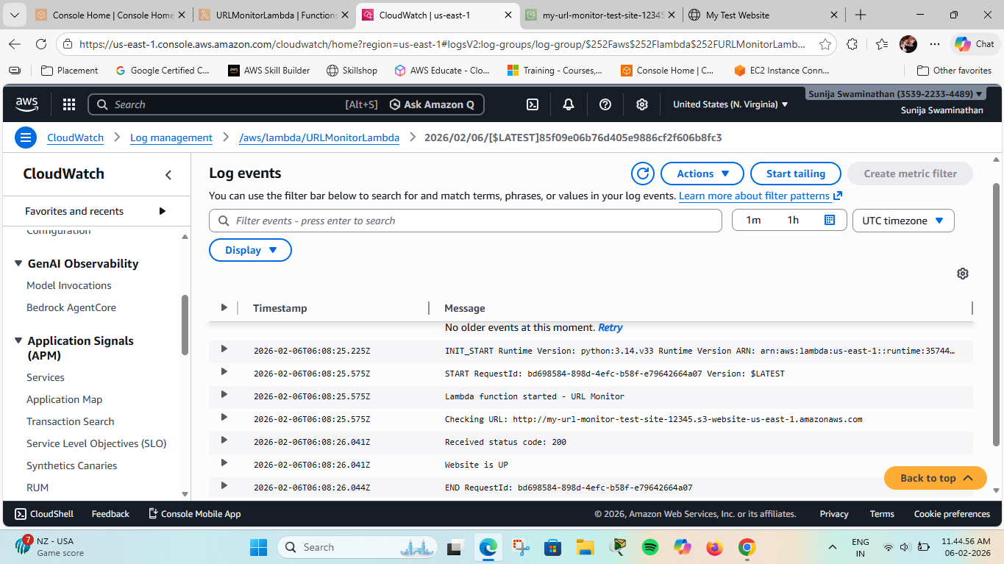
If status is not 200:
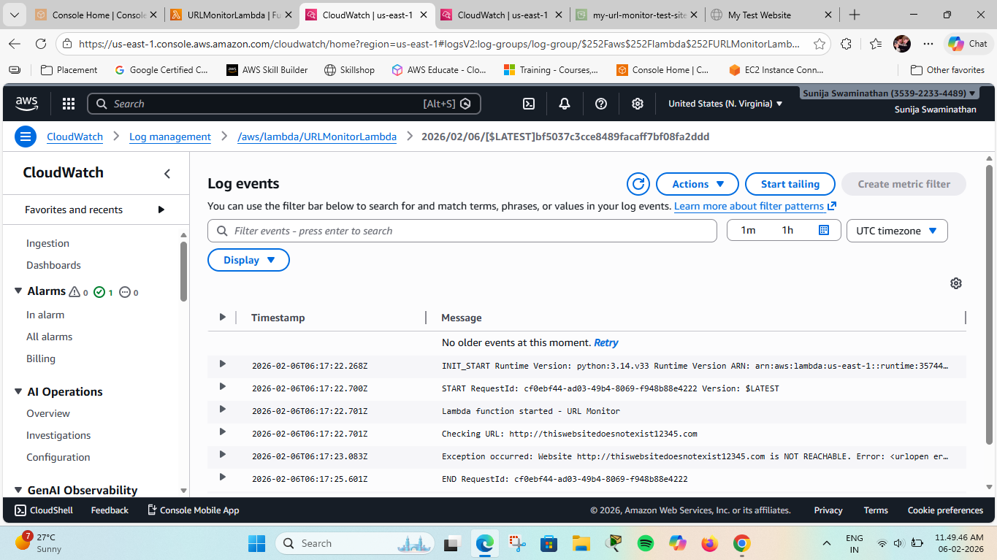

Sample S3 static website:
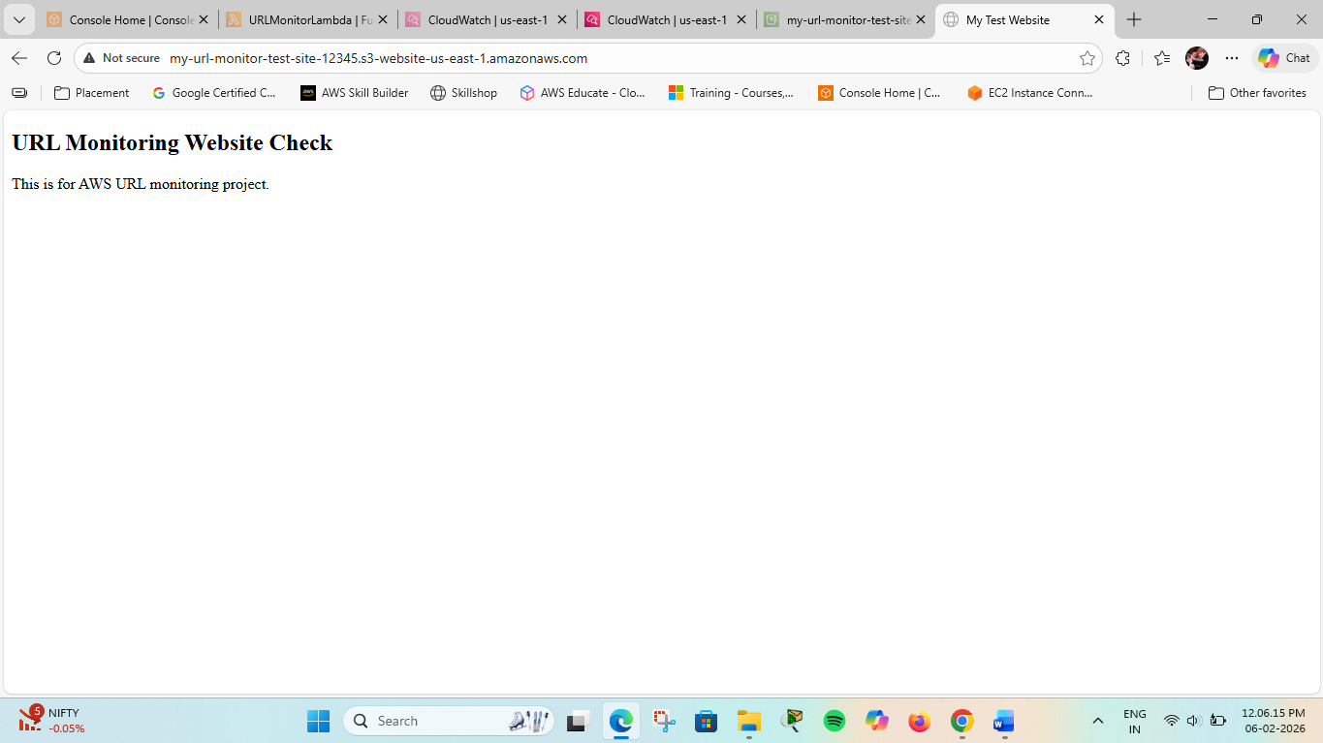

Email Notification:
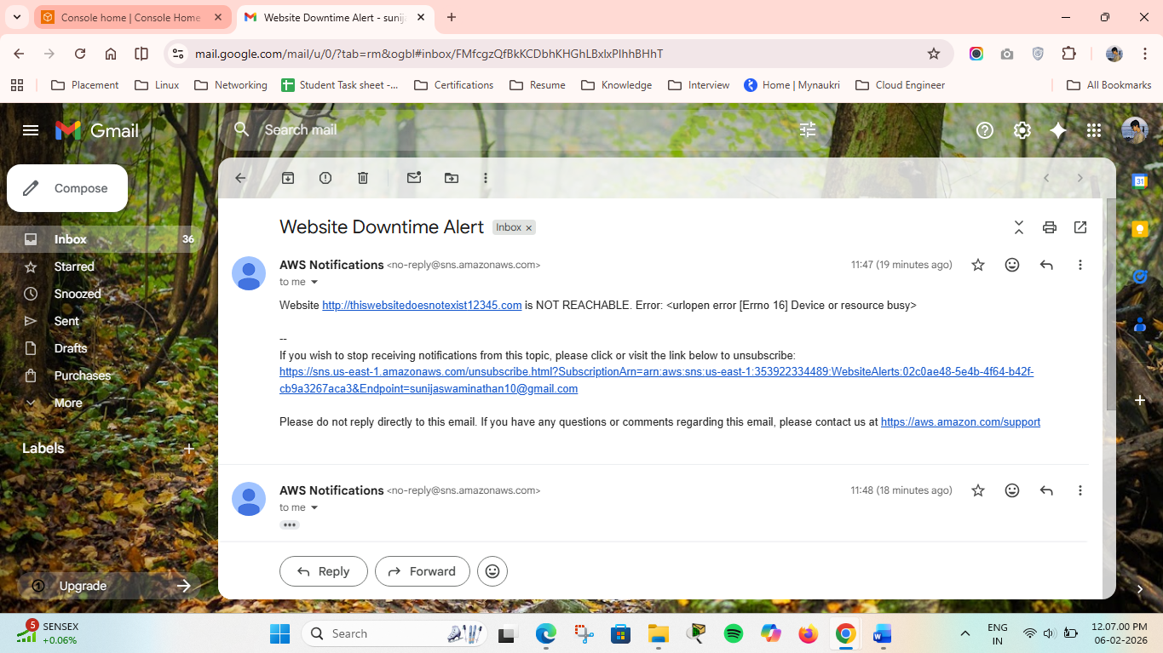

Every 5 min notification appears:
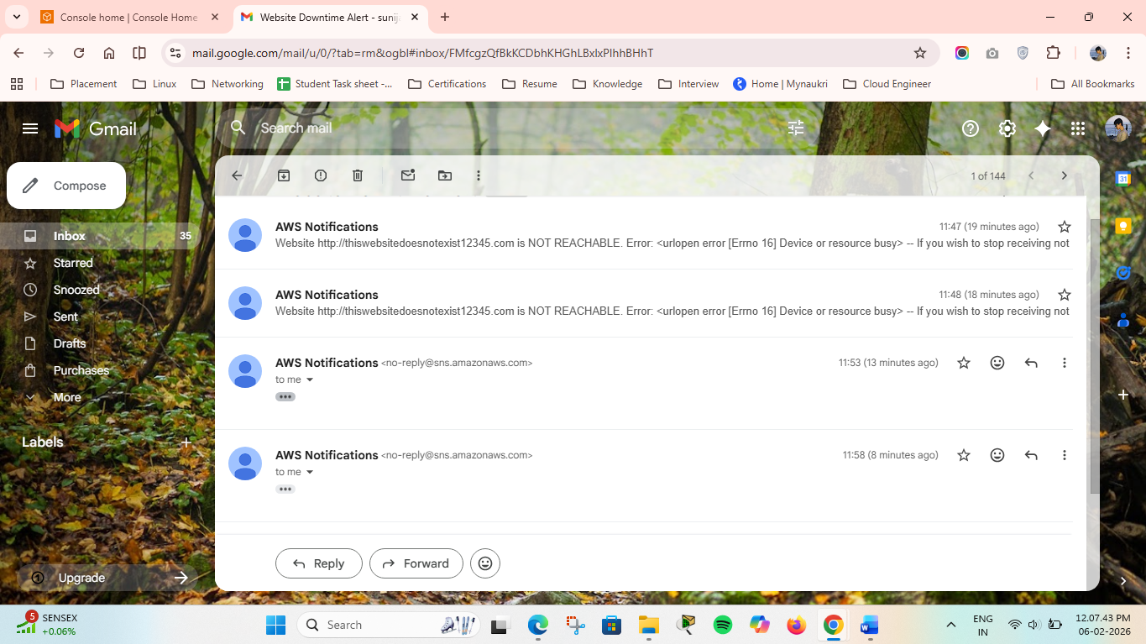

Lambda Function:
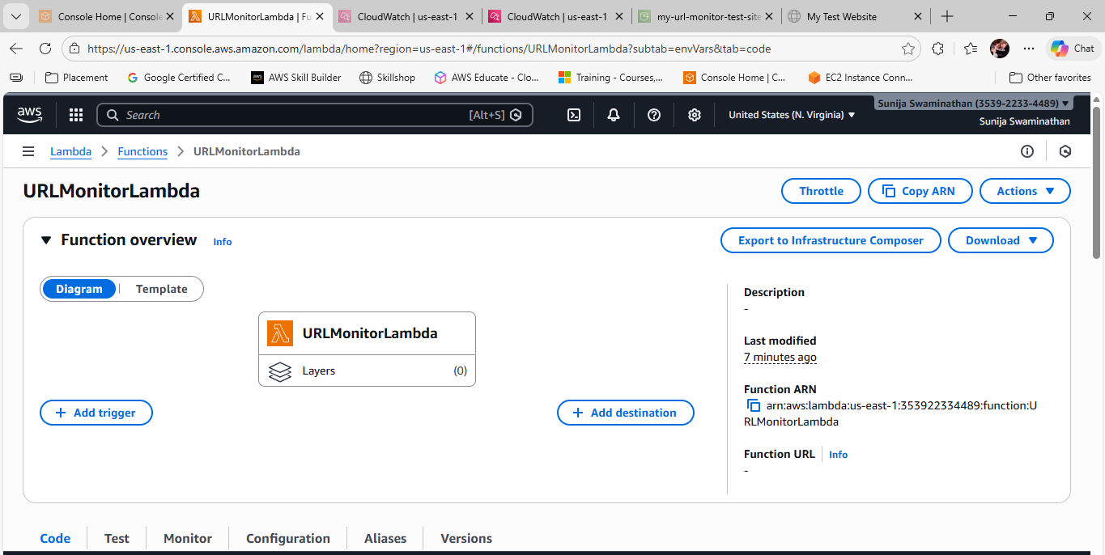

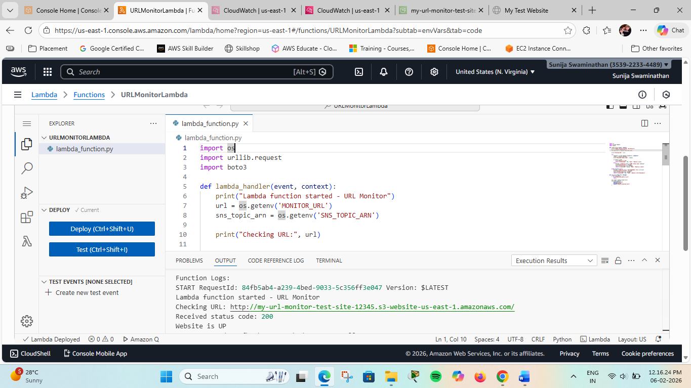

Environment Variables:
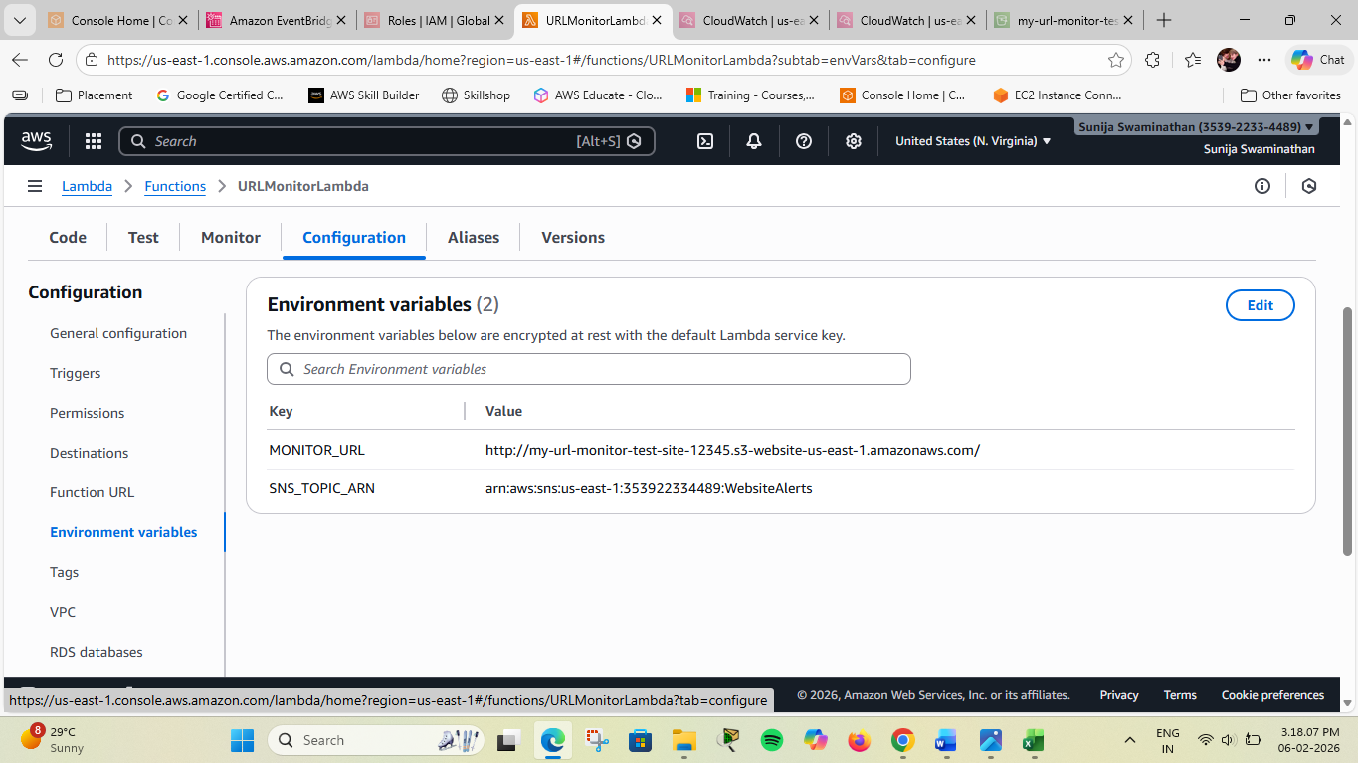

Amazon Event Bridge Schedule:
